|  |
| --- |
| Customer Data Standards |
| TC-CDS-1.2 |

[](http://www.google.com.au/url?sa=i&rct=j&q=hastings+deering&source=images&cd=&cad=rja&docid=IeOyUDzmar_E6M&tbnid=Kvq4Ow9b6GV0_M:&ved=0CAUQjRw&url=http://justdigitalsignage.com.au/case-studies/hasting-deering-australia/&ei=d2GAUfD7D8PHkwW_z4CgCw&bvm=bv.45645796,d.aGc&psig=AFQjCNFmmy-MjbWBqxLP_gw-y3dRKqkyGw&ust=1367454450714662)

Contents

1. PROBLEM STATEMENT 2

2. Purpose 2

3. Scope 2

4. OWNERSHIP STRUCTURE 2

5. Document History 3

5.1. Document information 3

5.2. Document amendment history 3

CUSTOMER ACCOUNTS 5

CREDIT 5

CUSTOMER ACCOUNTS 7

CASH 7

CUSTOMER EQUIPMENT 10

CUSTOMER CONTACTS 13

CUSTOMER SALES REP 15

1. PROBLEM STATEMENT

Poor data quality impacting our customer experience, digital transformation, business insights, and frontline activities

1. Purpose

Customer, equipment, contact and sales person data integrity – ensuring records are current, complete, and consistent

1. Scope

Customer, equipment, contact and sales person master data in NAXT (ERP) for - Terra Cat

1. OWNERSHIP STRUCTURE

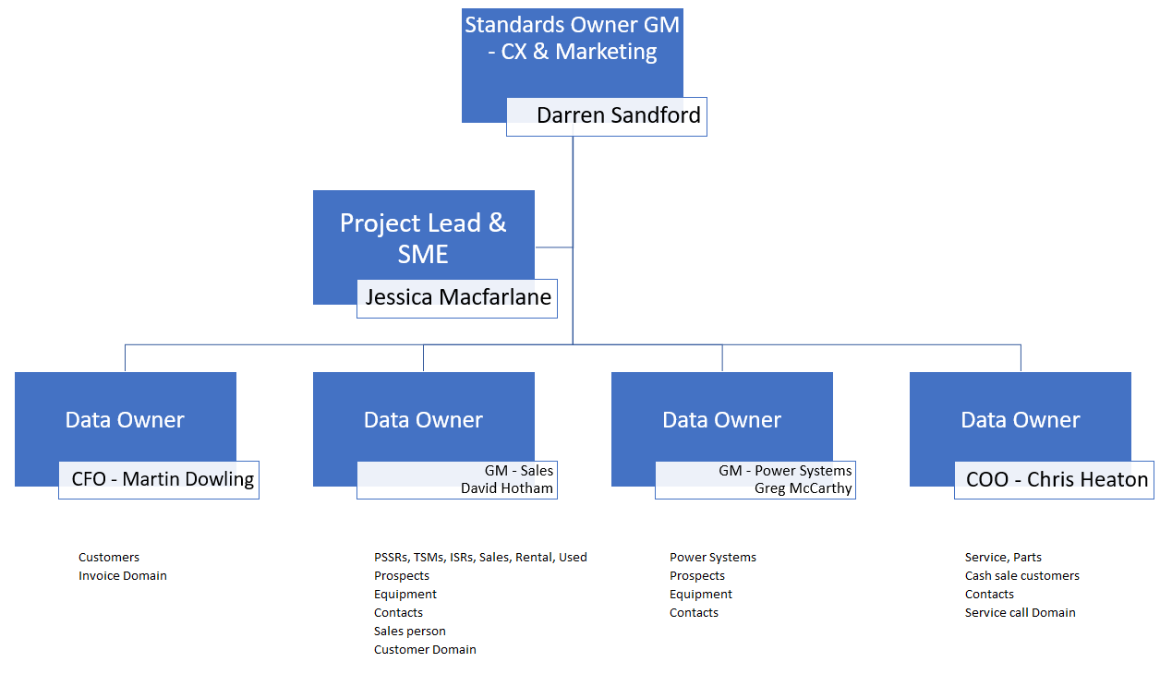

**Data Owners** are accountable for maintaining data integrity, ensuring adherence to established data standards and change management

1. Document History
   1. Document information

|  |  |
| --- | --- |
| **Current Version** | 1.2 |
| **Release Date** | 10 September 2020 |
| **Document Owner** | Jessica Macfarlane |

* 1. Document amendment history

|  |  |  |  |
| --- | --- | --- | --- |
| **Version** | **First Release** | **Section(s) Amended** | **Summary of Amendment** |
| 1.2 | 10/09/2020 | Rule 15 of Customers | Exception added for guest users |
| 1.1 | 11/05/2020 | n/a |  |
|  |  |  |  |
|  |  |  |  |
|  |  |  |  |

DATA DOMAIN 1:

CUSTOMER ACCOUNTS

CUSTOMER ACCOUNTS

CREDIT

| **BUSINESS RULES** | |
| --- | --- |
| Rule 1 | The Business ERP (NAXT) must be the "One Source of Truth" for Customer information across the Business |
| Rule 2 | Any Business application containing Customer information must be consistent with NAXT, primarily CRM (SalesLink) |
| Rule 3 | Account numbers must be generated by NAXT and must be unique |
| Rule 4 | Credit accounts must only be created by Credit team for transactional purposes |
| Rule 5 | All account addition requests must be checked in NAXT for potential duplication before creation - NAXT must flag duplicates |
| Rule 6 | Every Customer account must be set up with a primary Division and a primary Industry Code |
| Rule 7 | There must only be 1 Customer account created in NAXT per Customer legal entity (NZBN) for all transactions |
| Rule 8 | Customers operating at multiple sites can have multiple accounts but only 1 account per site with the following naming convention:  "Registered legal name (Site name)" Example: Downer NZ Pty Ltd (Auckland) |
| Rule 9 | Credit limits for each Customer account will be managed by Credit controllers |
| Rule 10 | Only the Credit team must have access to administer Credit Limits for Customers in NAXT - "Credit Limit by Business Area" |
| Rule 11 | Only nominated Marketing Gatekeepers and the Credit team must have access to perform any updates to Customer Master data |
| Rule 12 | All requests to close Customer accounts must be validated and documented with written communication |
| Rule 13 | All Customer accounts to be closed must be deactivated to prevent further transactions - Naming convention must not include "Do Not Use". It should include the current business practice of adding “XXX” to the customer name as a prefix. |
| Rule 14 | When a Customer account is closed, any Equipment records must be transferred to the new Owner account or be made inactive. Only nominated CSC and Marketing Gatekeepers should update Equipment. |
| Rule 15 | Customers transacting online (PCC) who aren’t guest users must have accounts created in NAXT |
| Rule 16 | NAXT user access levels and system functionality must be in accordance with established Business rules |
| Rule 17 | Data Owners are accountable for adherence to established Data standards and ongoing Data integrity |
| Rule 18 | Nominated SMEs must ensure Business rules and Data standards developed are feasible across all impacted Business areas and work with Data Owners on change management |
| Rule 19 | Retention of Customer records must be in accordance with local regulations |
| Rule 20 | Any changes and exceptions to these rules must be approved by the Data Standards Owner |

CUSTOMER ACCOUNTS

CASH

| **BUSINESS RULES** | |
| --- | --- |
| Rule 1 | The Business ERP (NAXT) must be the "One Source of Truth" for Customer information across the Business |
| Rule 2 | Any Business application containing Customer information must be consistent with NAXT, primarily CRM (SalesLink) |
| Rule 3 | Account numbers must be generated by NAXT and must be unique |
| Rule 4 | Cash Sale accounts must be administered by the nominated cash sale Gatekeepers for transactional purposes |
| Rule 5 | All account addition requests must be checked in NAXT for potential duplication before creation - NAXT must flag duplicates |
| Rule 6 | The following steps must be taken before an account is created:  1. Search in NAXT (ERP) or SalesLink (CRM) if the Customer already exists  2. Ask "Have you purchased from us before?" If yes, utilise existing account. If no, move to step 3 below  3. Ask "Do you intend to purchase from us again?" If yes, encourage a Customer account to be created. If no, use the branch cash sale account |
| Rule 7 | If a Customer account is created, the minimum requirements are Customer name, address, and contact details |
| Rule 8 | Every Customer account must be set up with a primary Division and a primary Industry Code |
| Rule 9 | There must only be 1 Customer account created in NAXT per Customer legal entity (NZBN) for all transactions – If there is already a trade account, a cash sale account must not be created |
| Rule 10 | Customers operating at multiple sites can have multiple accounts but only 1 account per site with the following naming convention:  "Registered legal name (Site name)" Example: Downer and Company Limited (Auckland) |
| Rule 11 | Nominated Marketing Gatekeepers and the Credit team must have access to perform any updates to Customer Master data |
| Rule 12 | All requests to close Customer accounts must be validated and documented with written communication |
| Rule 13 | All Customer accounts to be closed must be deactivated to prevent further transactions - Naming convention must not include "Do Not Use". Closed accounts must have prefix ‘XXX’ added to the customer name field. |
| Rule 14 | When a Customer account is closed, any Equipment records must be transferred to the new Owner account or be made inactive |
| Rule 15 | Customers transacting online (PCC) who aren’t guest users must have accounts created in NAXT |
| Rule 16 | NAXT user access levels and system functionality must be in accordance with established Business rules |
| Rule 17 | Data Owners are accountable for adherence to established Data standards and ongoing Data integrity |
| Rule 18 | Nominated SMEs must ensure Business rules and Data standards developed are feasible across all impacted Business areas and work with Data Owners on change management |
| Rule 19 | Retention of Customer records must be in accordance with local regulations |
| Rule 20 | Any changes and exceptions to these rules must be approved by the Data Standards Owner |

DATA DOMAIN 2:

CUSTOMER EQUIPMENT

CUSTOMER EQUIPMENT

| **BUSINESS RULES** | |
| --- | --- |
| Rule 1 | The Business ERP (NAXT) must be the "One Source of Truth" for Customer Equipment across the Business |
| Rule 2 | Any Business application containing Customer Equipment must be consistent with NAXT, primarily CRM (SalesLink) |
| Rule 3 | Accurate Equipment Population is imperative; all Equipment add, delete, ownership change, or update requests must be submitted through SalesLink; Equipment additions from Service will follow the NAXT Equipment workflow process |
| Rule 4 | Equipment records in NAXT must only be updated by:   * Sales Administrators / Coordinators - New, Used and Rental Machine sales * Nominated Marketing Gatekeepers - All other additions, deletions, and updates to Customer Owned fleet (Population) |
| Rule 5 | All users requesting for Equipment additions must first check in SalesLink if the Equipment already exists; This also applies to users authorised to create records in NAXT - system must flag duplicate records before creation |
| Rule 6 | All required inputs must be made mandatory in NAXT and must be complete and valid |
| Rule 7 | All Equipment must be setup against the Country and Site account of where it is operating |
| Rule 8 | If the Equipment is sold on an account (e.g. Head Office) that differs to the actual location, it must be transferred to the country and site account of where it is physically operating post Sale |
| Rule 9 | Equipment serial numbers in NAXT must be unique and must align with SIMSi |
| Rule 10 | Equipment reference data must be complete, accurate, and centrally controlled - updated as per NPI process for Caterpillar make |
| Rule 11 | Equipment divisions must be aligned to the Terra Cat Product Division structure |
| Rule 12 | Competitive Equipment: All non-CAT makes including lost sale records in CRM must be captured in the Customers Equipment population in NAXT |
| Rule 13 | All Equipment with Fleet Type = Customer or Competitor and with no Customer assigned must be made Inactive until the Ownership is determined |
| Rule 14 | Equipment being parked by the Customer for an indefinite period must be flagged as "Parked" and updated to "Active" when working again |
| Rule 15 | Equipment usage in NAXT must capture SMU readings from all relevant business applications (e.g. Vision Link, Oil Commander, VIMS) including manual entries |
| Rule 16 | Out of Territory and Scrapped Equipment must be made Inactive in NAXT |
| Rule 17 | NAXT user access levels and system functionality must be in accordance with established Business rules |
| Rule 18 | Data Owners must ensure Business rules and Data standards developed are adhered to and ongoing data errors identified are actioned in line with established Business procedures |
| Rule 19 | Nominated SMEs must ensure Business rules and Data standards developed are feasible across all impacted Business areas and work with Data Owners on change management |
| Rule 20 | Any changes and exceptions to these rules must be approved by the Data Standards Owner |

*\* Only for Fleet Type ≠ ‘Customer’ and Fleet Type ≠ ‘Competitive’*

DATA DOMAIN 3:

CUSTOMER CONTACTS

CUSTOMER CONTACTS

| **BUSINESS RULES** | |
| --- | --- |
| Rule 1 | The Business ERP (NAXT) must be the "One Source of Truth" for Customer Contacts across the Business |
| Rule 2 | Any Business application containing Customer Contacts must be consistent with NAXT, primarily SalesLink (CRM) |
| Rule 3 | Every Customer Contact must have a First Name, Last Name, Phone Number, and Email Address as a minimum |
| Rule 4 | There must be Customer Contacts nominated on each account to participate in Customer surveys unless they opt out |
| Rule 5 | There should only be 1 Customer Contact per account for each survey type or for a combination of multiple surveys (New Sales, Rental, Parts, Service) |
| Rule 6 | Customer Contacts opting not to be contacted must be flagged in NAXT |
| Rule 7 | All Customer Contact additions and updates must be performed through CRM; additions may also be performed through the Credit application process for new Customer accounts |
| Rule 8 | Only nominated Marketing Gatekeepers and the Credit team must have access to create or edit Customer Contacts in NAXT |
| Rule 9 | All record addition requests must be checked in NAXT for potential duplication before creation - NAXT should flag duplicates |
| Rule 10 | All required inputs must be made mandatory in NAXT and must be complete and valid |
| Rule 11 | All Customer Contacts that are no longer relevant must be removed from the Customer record |
| Rule 12 | NAXT user access levels and system functionality must be in accordance with established Business rules |
| Rule 13 | Data Owners must ensure Business rules and Data standards developed are adhered to and ongoing data errors identified are actioned in line with established Business procedures |
| Rule 14 | Nominated SMEs must ensure Business rules and Data standards developed are feasible across all impacted Business areas and work with Data Owners on change management |

DATA DOMAIN 4:

CUSTOMER SALES REP

CUSTOMER SALES REP

| **BUSINESS RULES** | |
| --- | --- |
| Rule 1 | The Business ERP (NAXT) must be the "One Source of Truth" for Customer Sales Reps across the Business |
| Rule 2 | Any Business application containing Customer Sales Reps must be consistent with NAXT, primarily SalesLink (CRM) |
| Rule 3 | All required inputs must be made mandatory in NAXT and must be complete and valid |
| Rule 4 | Every Customer Sales Rep must have a unique NAXT Salesman code with the following convention in accordance with their area of responsibility:  Division + Location + number sequence  e.g. EEQROT01 (EEQ Equipment + ROT Rotorua + 01) |
| Rule 5 | A running sequence of Sales Rep codes must be centrally maintained by Marketing Gatekeepers |
| Rule 6 | All requests for Sales Rep setup must be received via the established Business process |
| Rule 7 | Only nominated Marketing Gatekeepers must have access to create Sales Reps in NAXT |
| Rule 8 | Line Managers must ensure that every Customer account has a Sales Rep assigned in accordance with their respective Customer coverage area |
| Rule 9 | Customer accounts must typically be assigned as follows:  1 x ISR or PSSR against EPT division  1 x EEQ against EEQ division  1 x POWER against EPS division |
| Rule 10 | Any Sales Rep no longer relevant against the assigned account must be removed and replaced accordingly |
| Rule 11 | Sales Reps codes must stay with the established Customer regions rather than with the Sales Reps |
| Rule 12 | NAXT user access levels and system functionality must be in accordance with established Business rules |
| Rule 13 | Data Owners must ensure Business rules and Data standards developed are adhered to and ongoing data errors identified are actioned in line with established Business procedures |
| Rule 14 | Nominated SMEs must ensure Business rules and Data standards developed are feasible across all impacted Business areas and work with Data Owners on change management |
| Rule 15 | Any changes and exceptions to these rules must be approved by the Data Standards Owner |